THE NEW ECG LED WIND-UP FLASHLIGHT

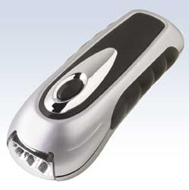

THE NEW ECG LED WIND-UP FLASHLIGHT HAS A ONE OR THREE LED SETTING.

NO MORE BATTERIES TO EVER BUY AGAIN.

NO MORE LOW-LIGHT SHAKE UP MODELS.

JUST WIND TO CHARGE.

CUSHION GRIPS.

FS-01BK---SILVER MODEL (AS SHOWN)
FS-01BL---BLUE MODEL

RETAIL COST: $10.00

BENTON ELECTRONICS
PH: 800-719-0069
FX: 269-925-5520

